# Week 9: Scrolling

# Content

* Download the sprites found on Moodle
  + Week 10 Content

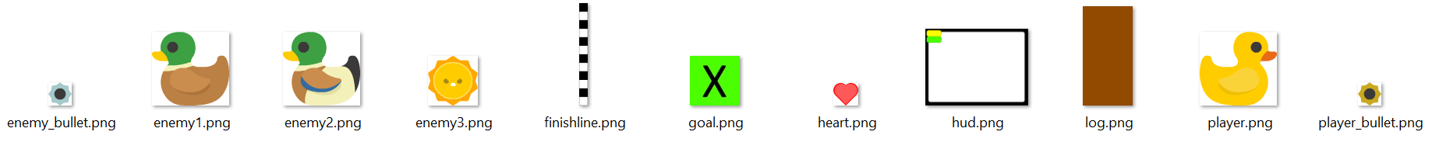

# Sprites

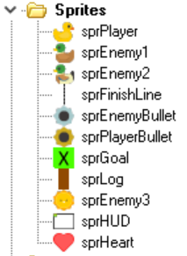

* sprPlayer
* Centered

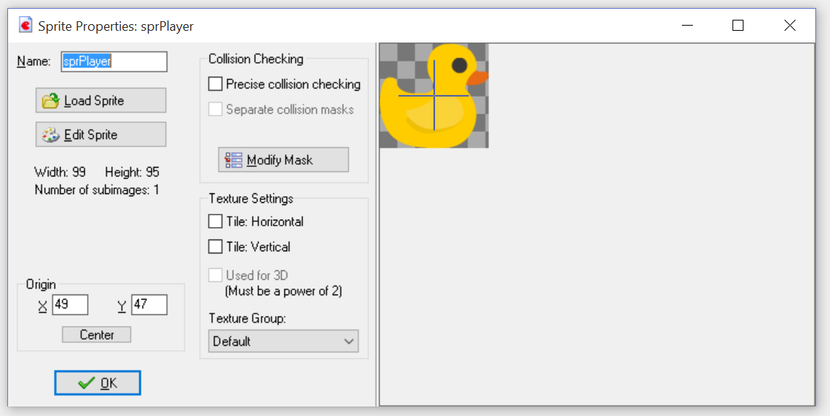

* sprEnemy1, sprEnemy2
* Not Centered

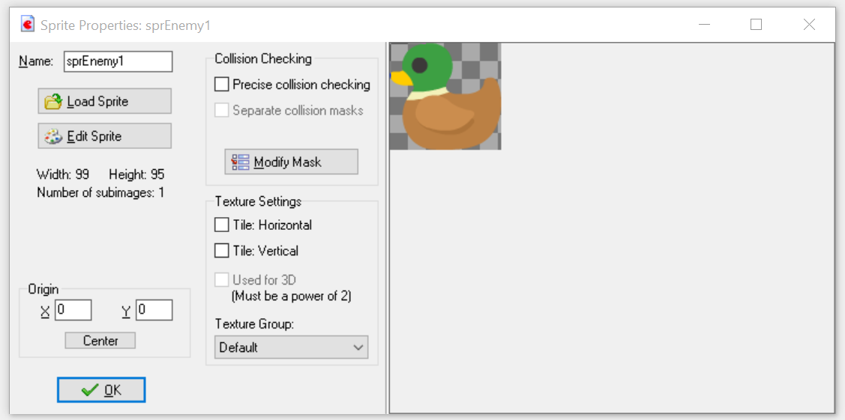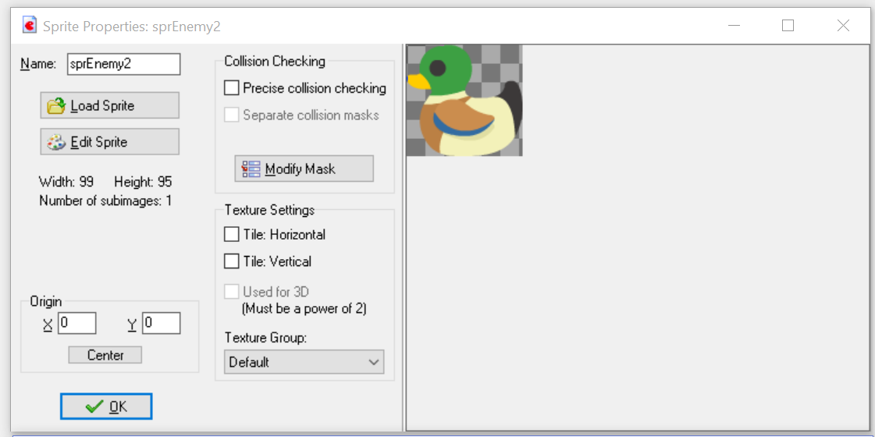

* sprEnemy3
* Centered

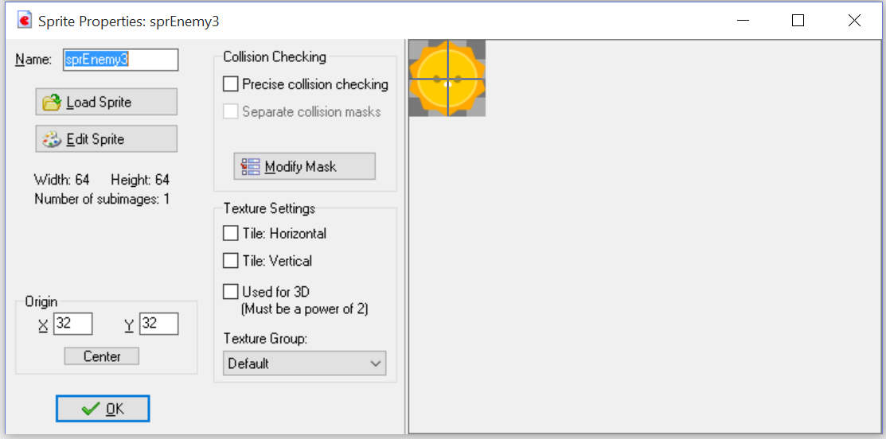

* sprGoal
* Not Centered

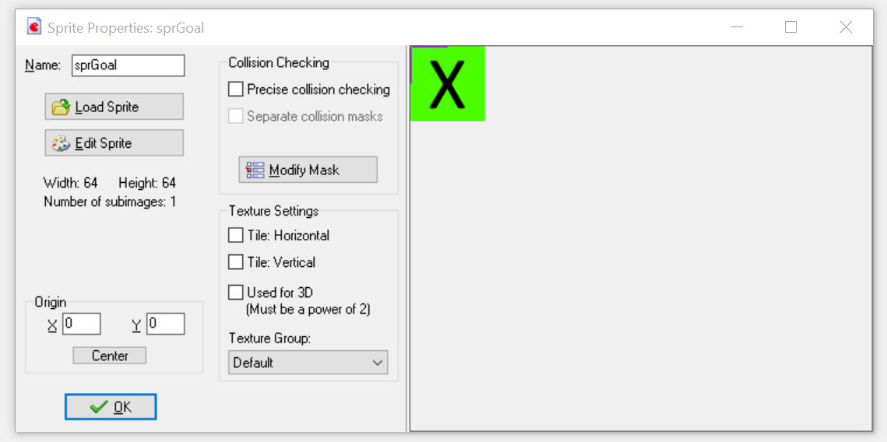

* sprPlayerBullet and sprEnemyBullet
* Centered

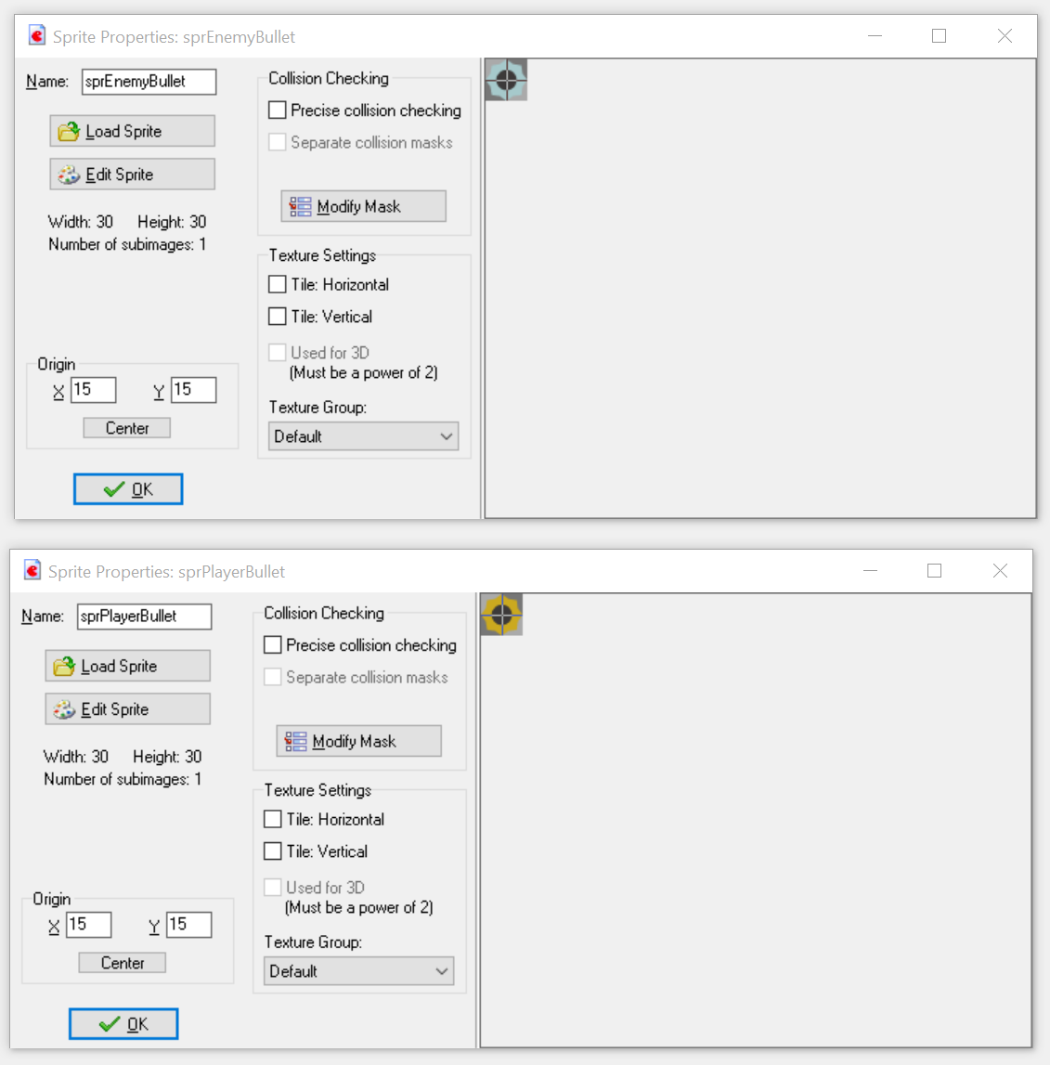

* sprFinishLine
* Not Centered

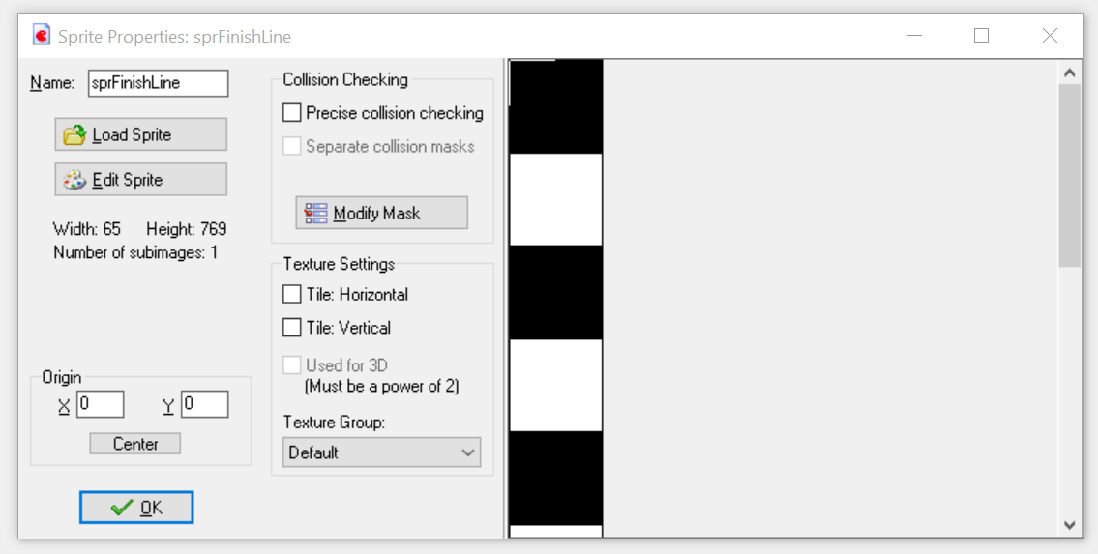

* sprHUD
* Not Centered

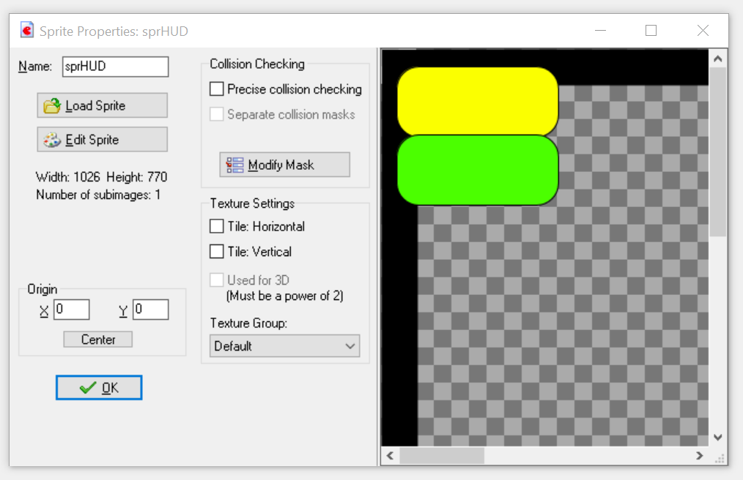

* sprHeart
* Not Centered

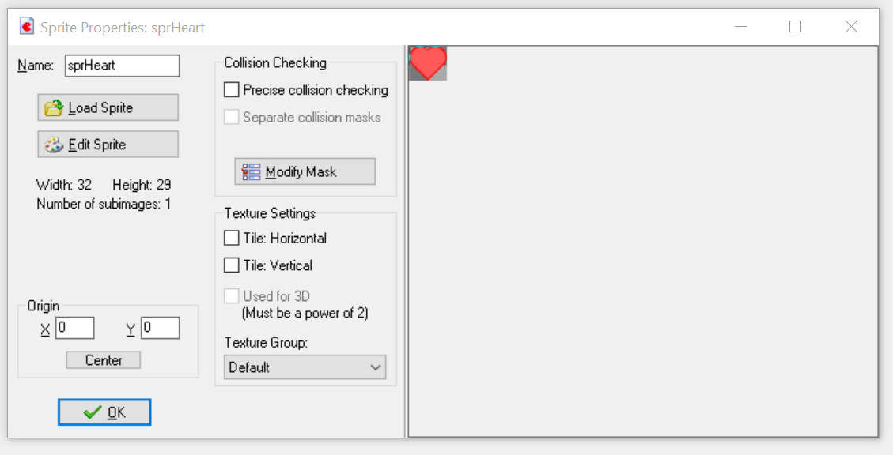

* sprLog
* Not Centered

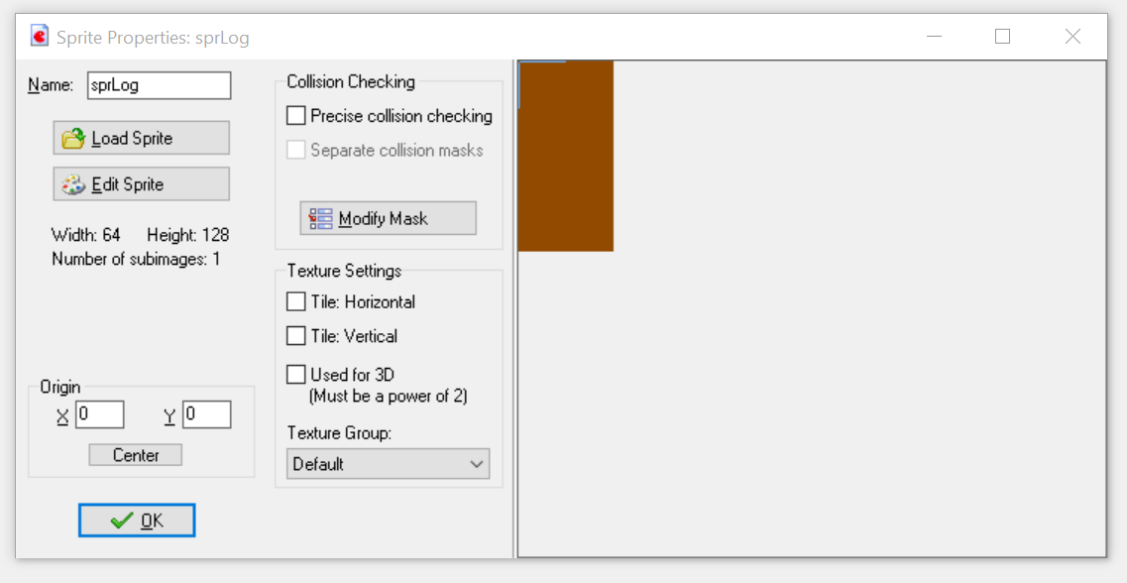

# Sounds

* Download the audio files from Moodle
* Each has already been named
* Load in the sound and add snd to each the name of each

# Fonts

* Create a new Font called bigFont
* Set the size to be 24

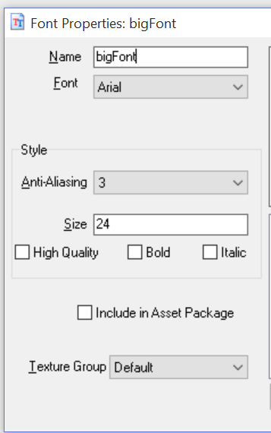

# Base Game Objects

* To create a new Game Object
* Right Click the Objects folder -> Select Create Object
* **Create each of the objects shown in the list below**
  + **Choose the correct sprite**
  + **Assign the correct name (spelling must be the same)**

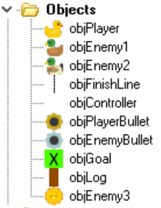

## Obj Player

* sprPlayer
* Not Solid

## Obj Enemy1

* sprEnemy1
* Not Solid

## Obj Enemy2

* sprEnemy2
* Not Solid

## Obj Enemy3

* sprEnemy3
* Not Solid

## obj controller

* No Sprite

## obj Finish Line

* sprFinishLine
* Not Solid

## obj Player Bullet

* sprPlayerBullet
* Not Solid

## obj Enemy Bullet

* sprEnemyBullet
* Not Solid

## obj Goal

* sprGoal
* Not Solid
* Not Visible

## obj Log

* sprLog
* Is Solid

# Room Layout

## Room Settings

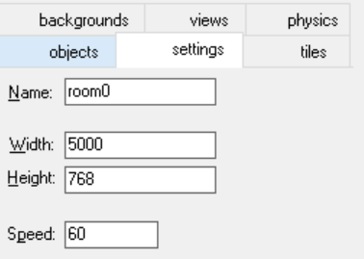

## View

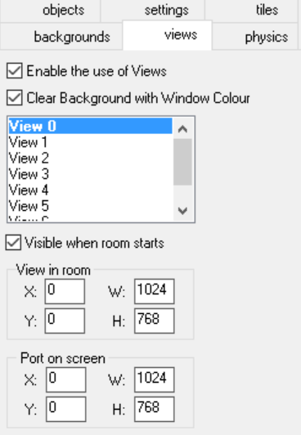

## Game Object Layout

* Layout an obstacle course of logs an enemies for the player to move through
* **Do not forget to add objController**
* **Ensure objFinishLine is at the end of the room, one cell in from the very left**
* **Ensure the objGoal covers the entire height of the room after the finish line**

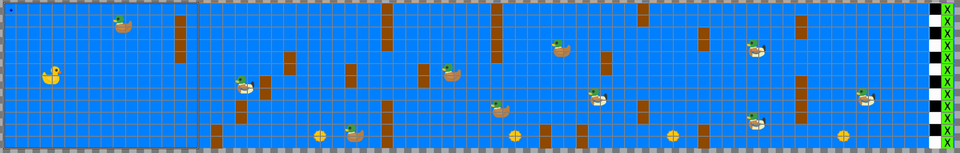

# Paths

* We require one path for objEnemy3
  + Vertical
* **Ensure the path is one cell from both the top and bottom of the room**

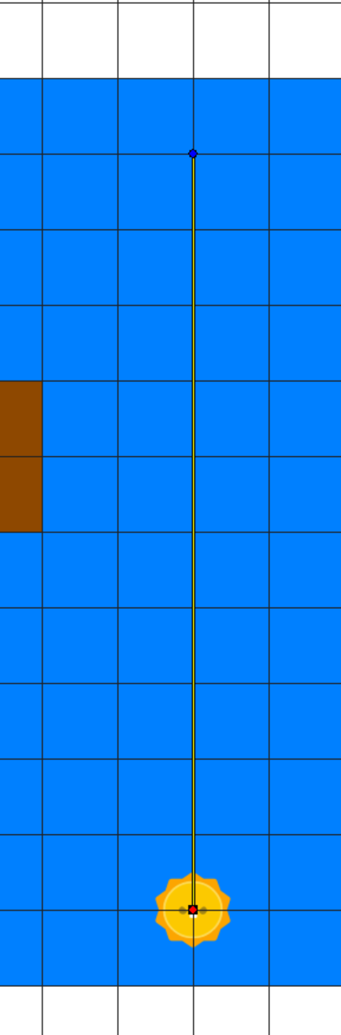

# Scripting Game Objects

## Obj Controller

### Create Event

* **The Alarm is not required**

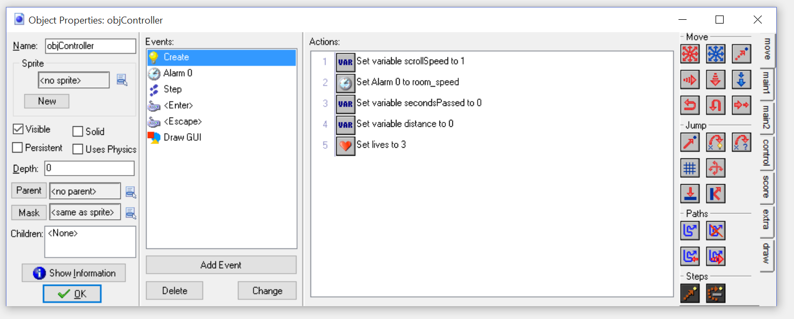

### Step Event

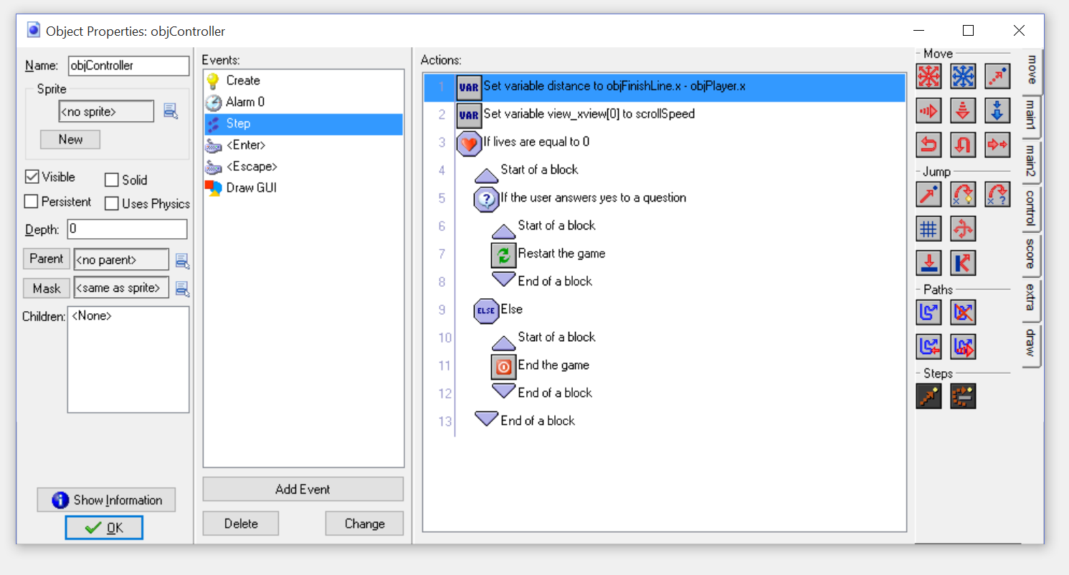

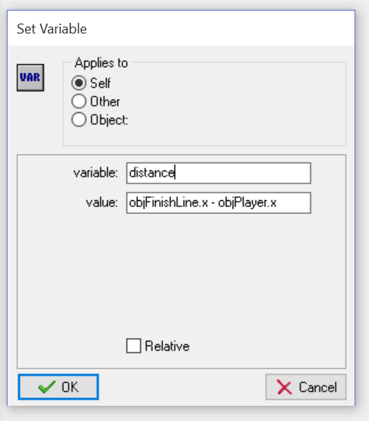 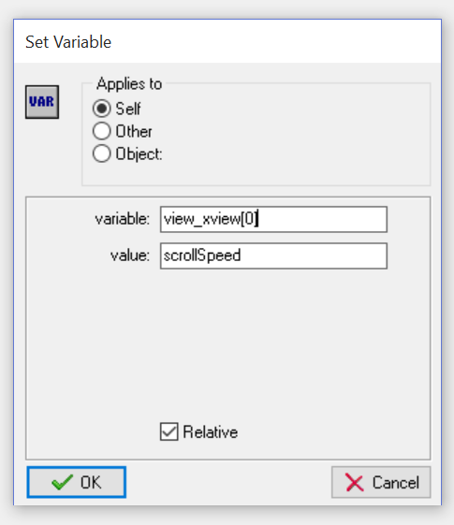

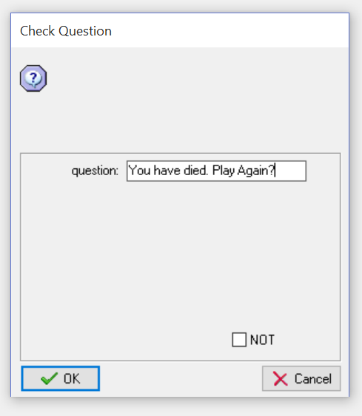

### Keyboard – Enter Event

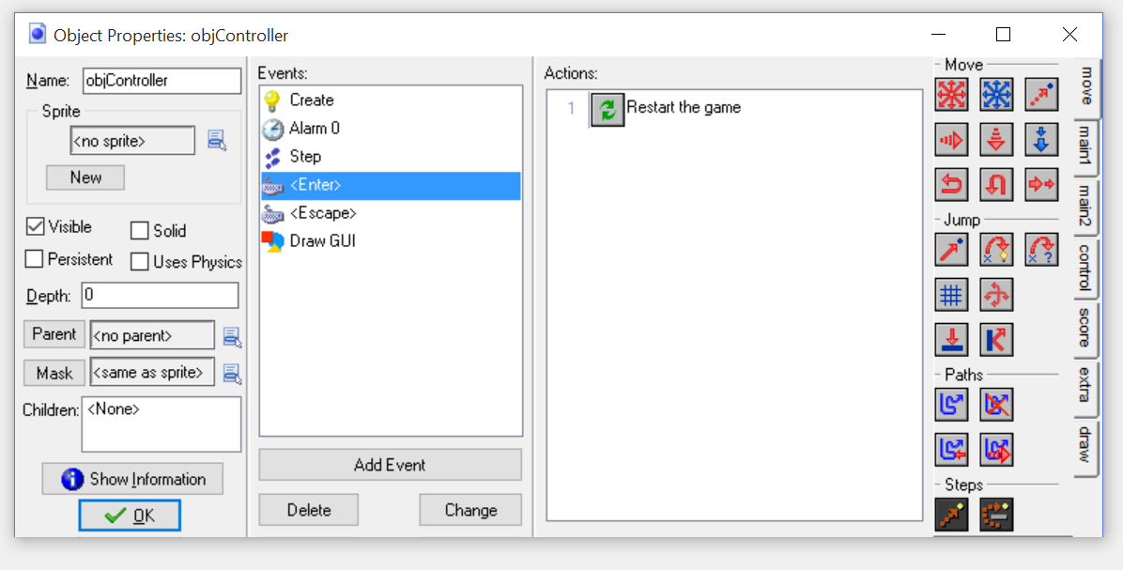

### Keyboard – Escape Event

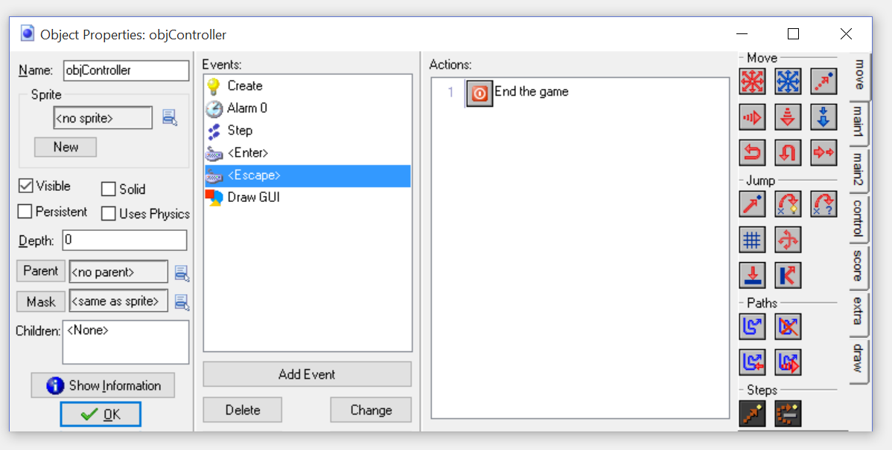

### Draw GUI

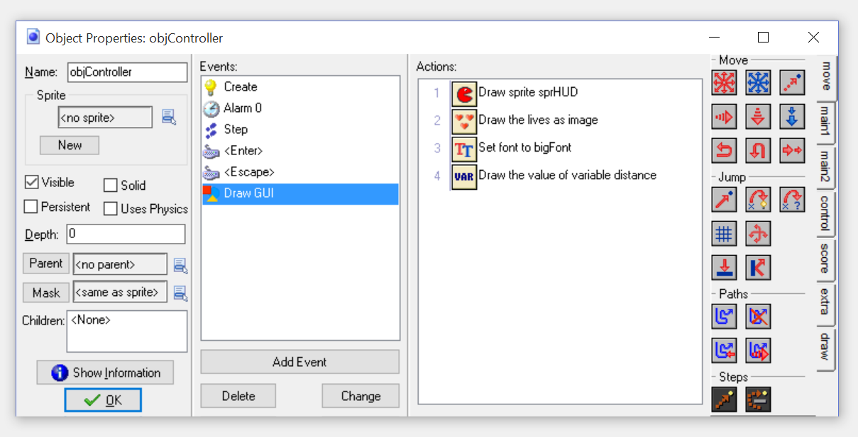

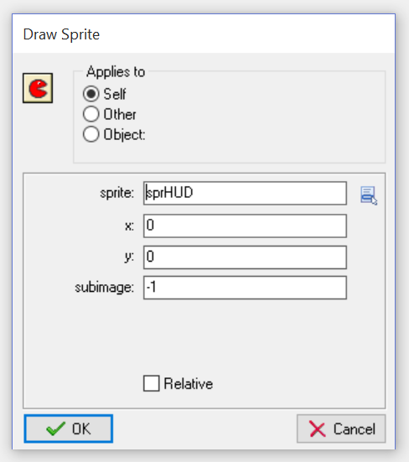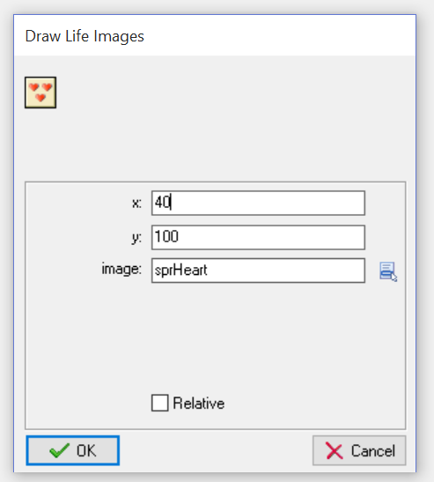

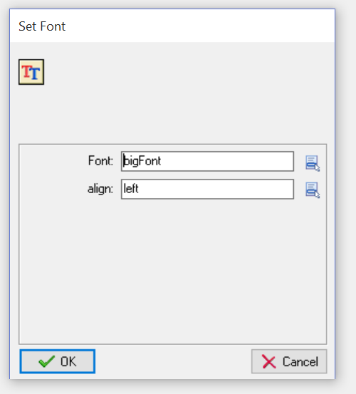 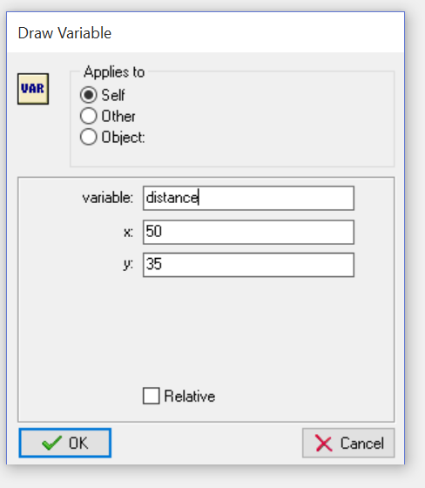

## Obj Enemy 1

* If the enemy hits a player bullet
  + Destroy the bullet (Other)
  + Destroy the enemy (Self)

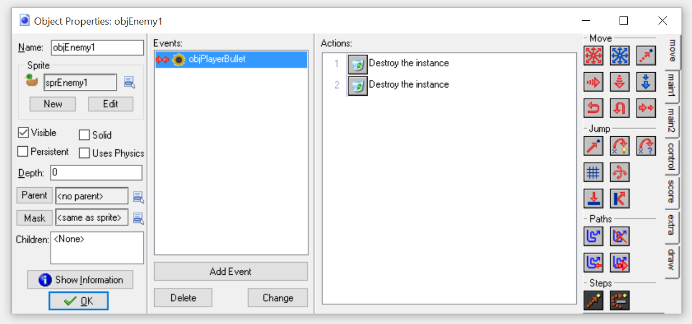

## Obj Enemy 2

### Create

* Set Alarm 0 to go off in 2 seconds (room_speed * 2)

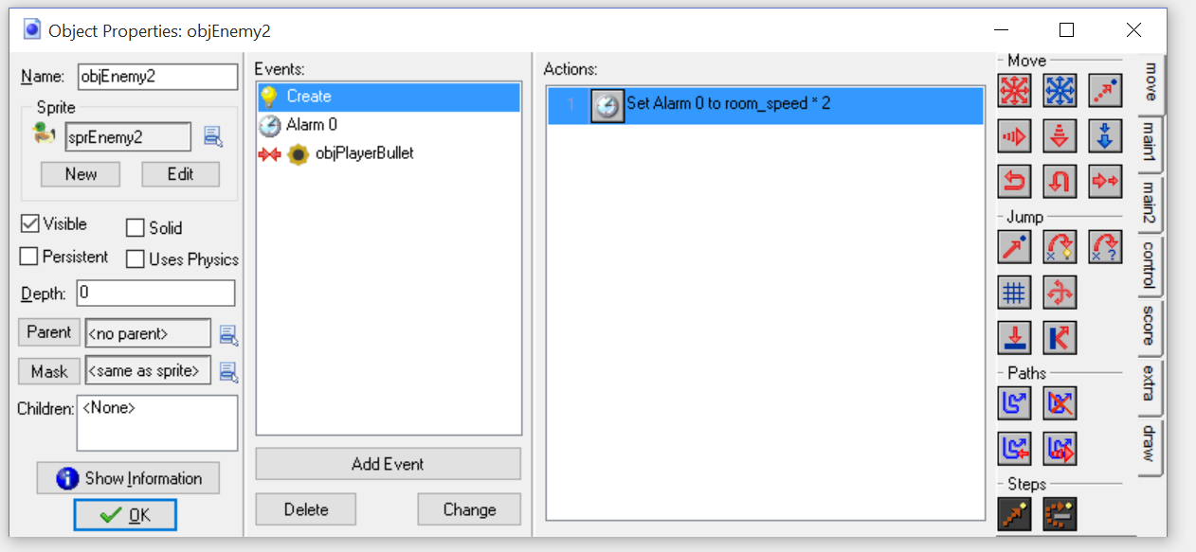

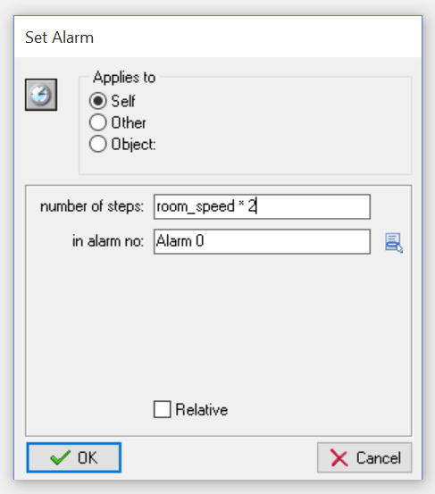

### Alarm0

* Create an enemy bullet
* Reset the alarm to go off in another 2 seconds

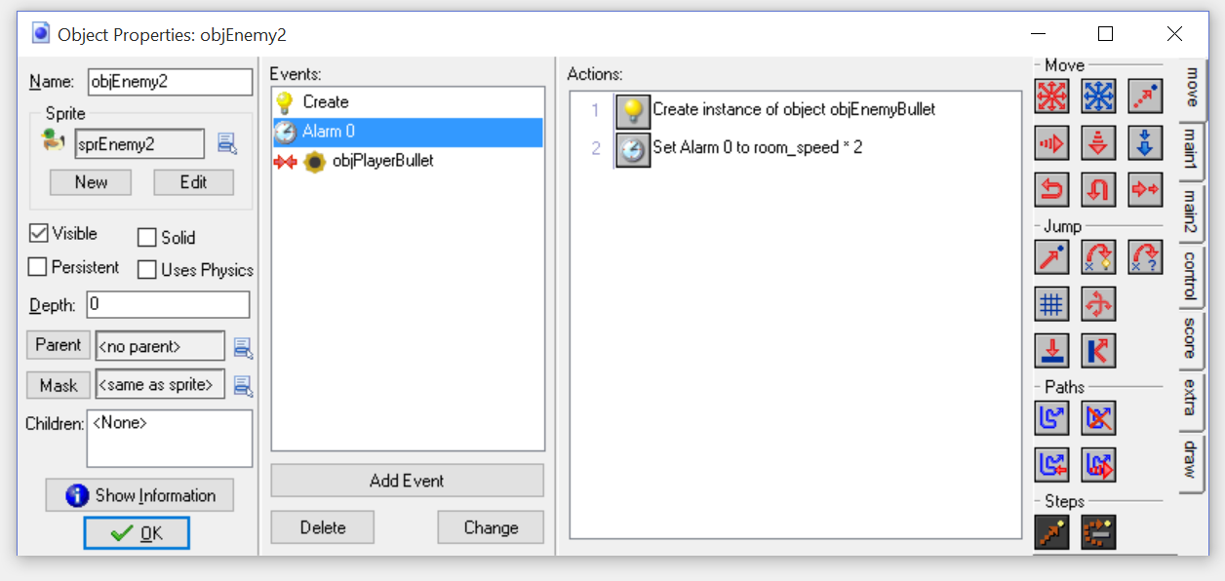

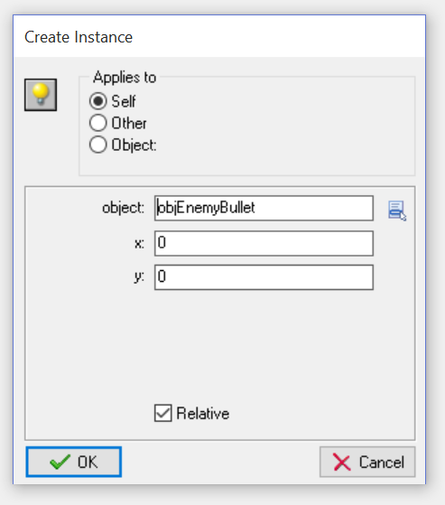 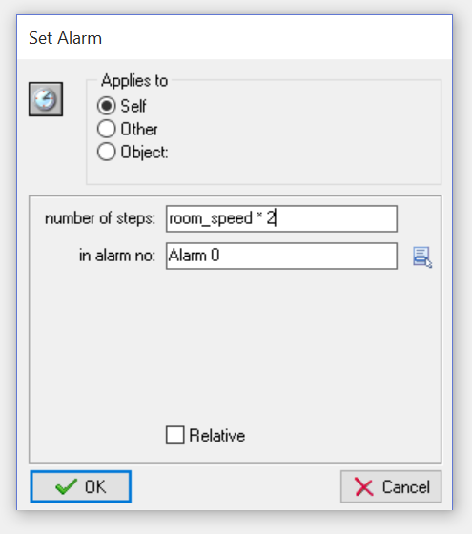

## Obj Enemy 3

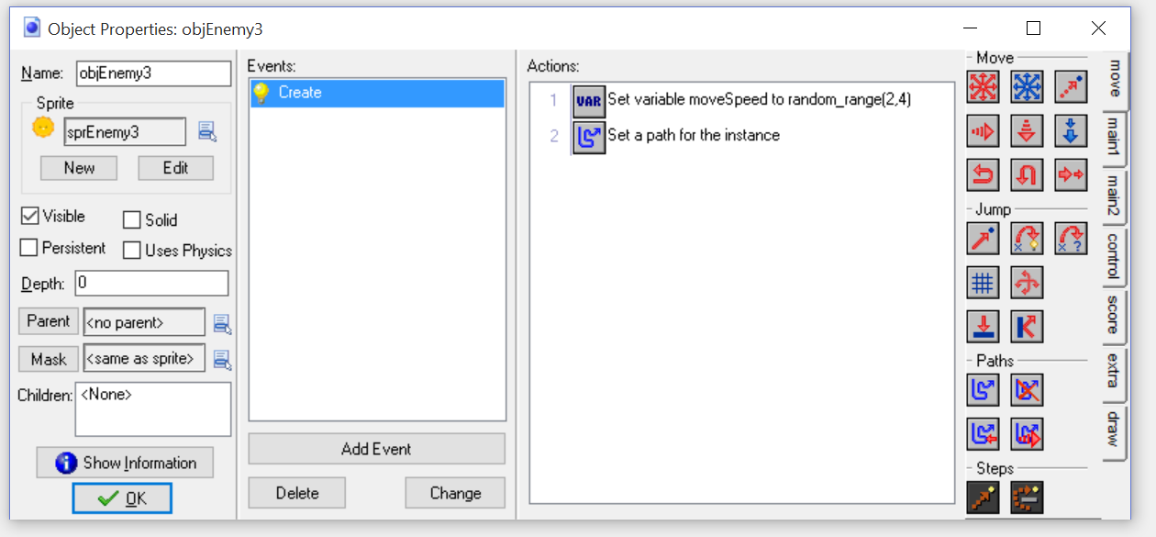

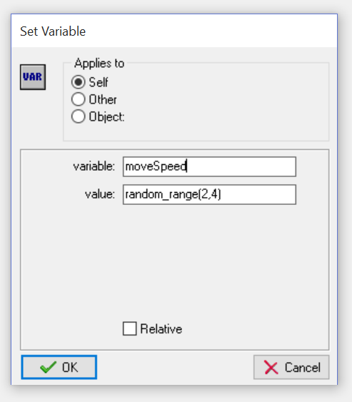 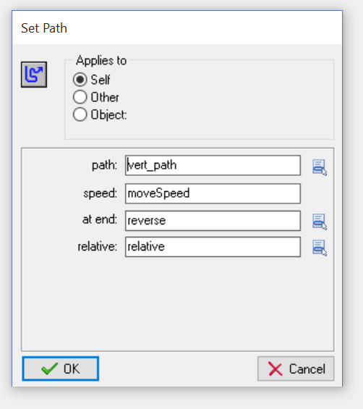

## Obj Enemy Bullet

### Create Event

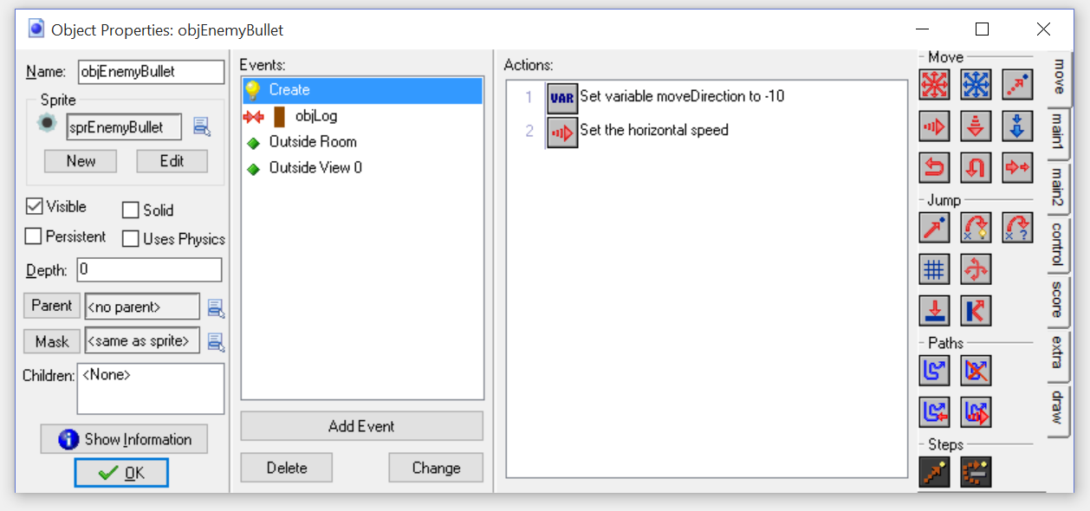

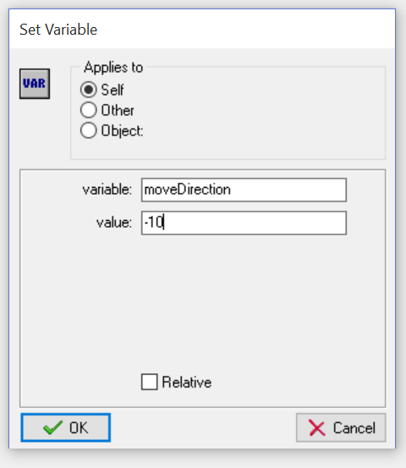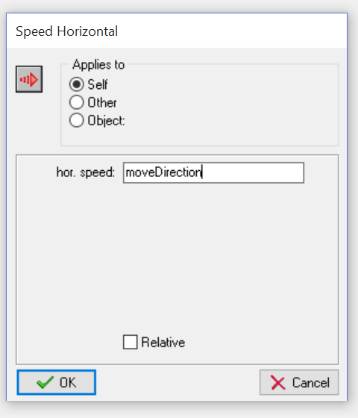

### Collision – Obj Log

* Destroy Self

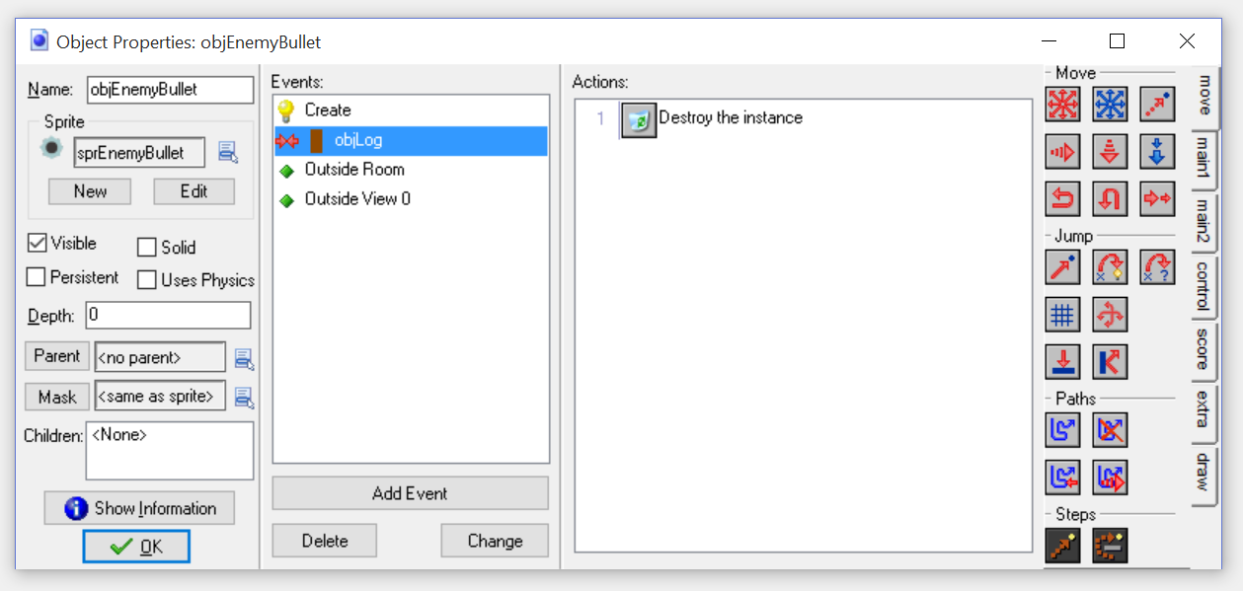

### Outside Room

* Destroy Self

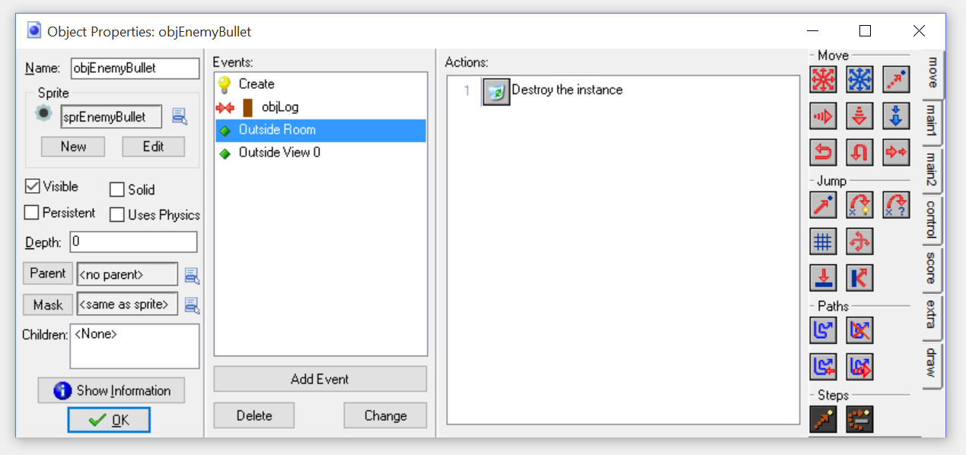

### Outside View 0

* Destroy Self

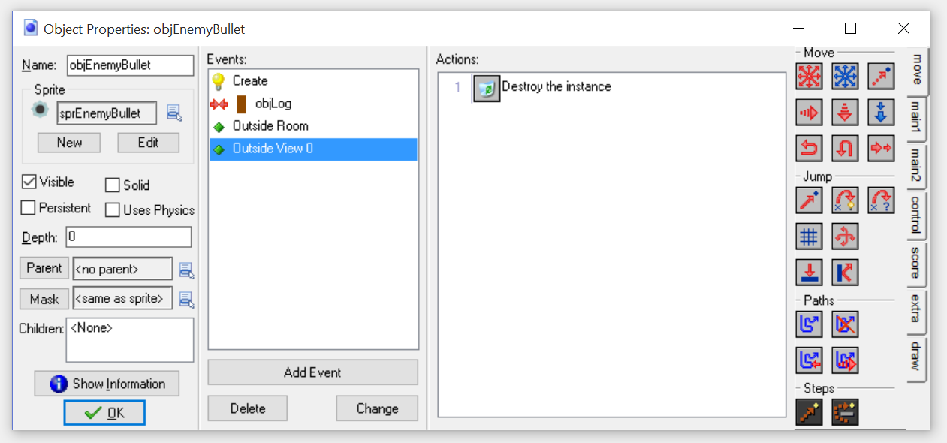

## Obj Player Bullet

### Create Event

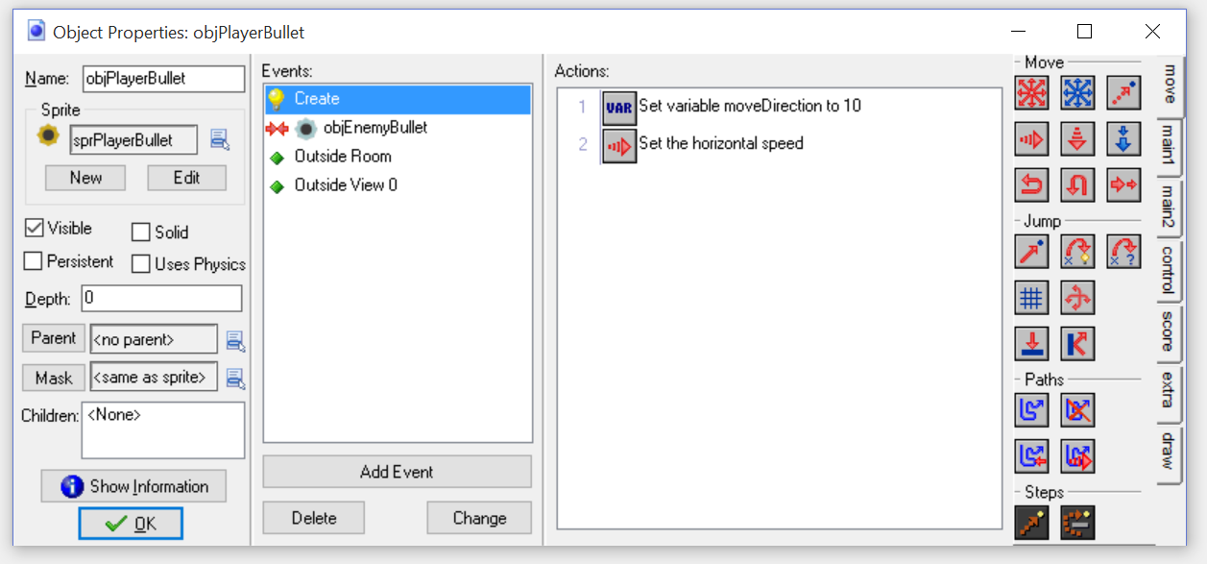

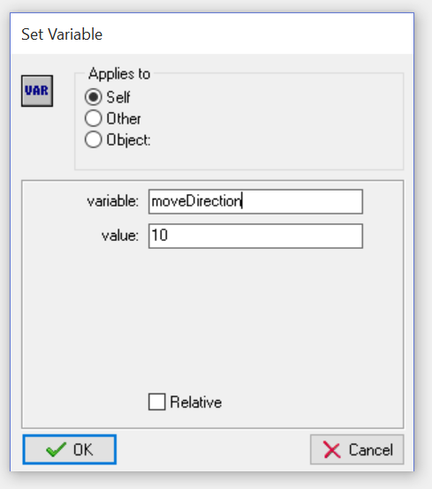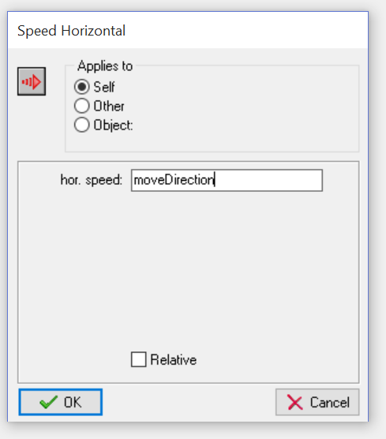

### Collision Obj Enemy Bullet

* Destroy both instances
  + Destroy Self and Destroy Other

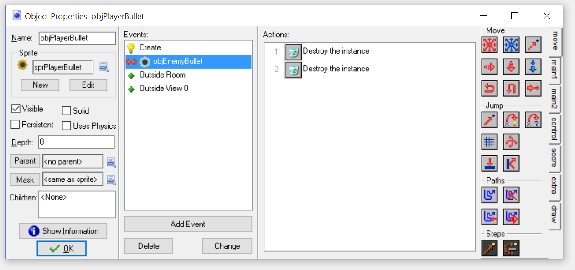

### Other- Outside Room

* Destroy Self

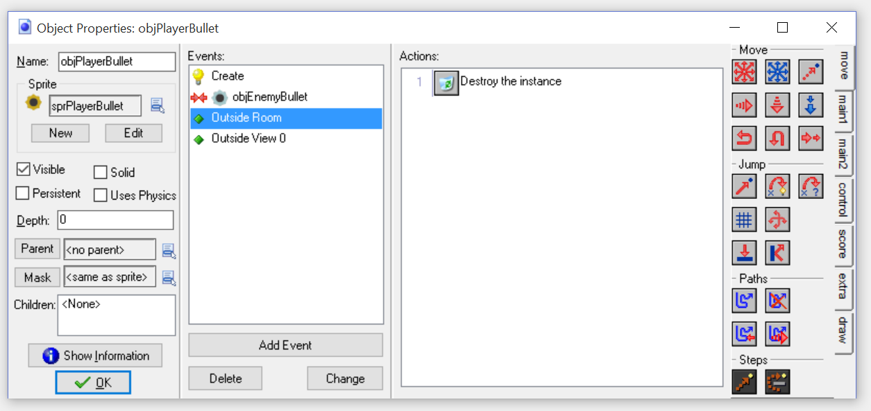

### Other – Outside View 0

* Destroy Self

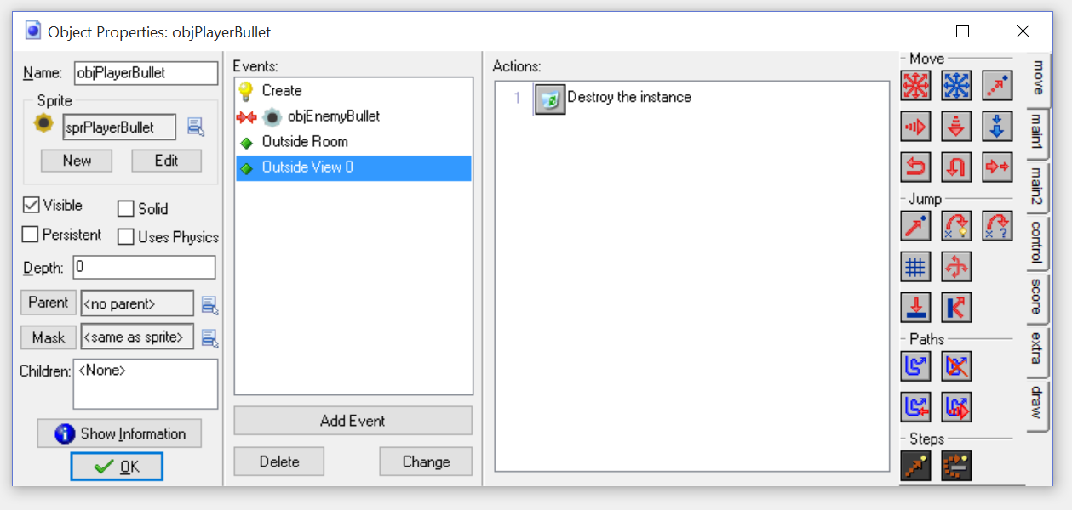

## Obj Player

### Create Event

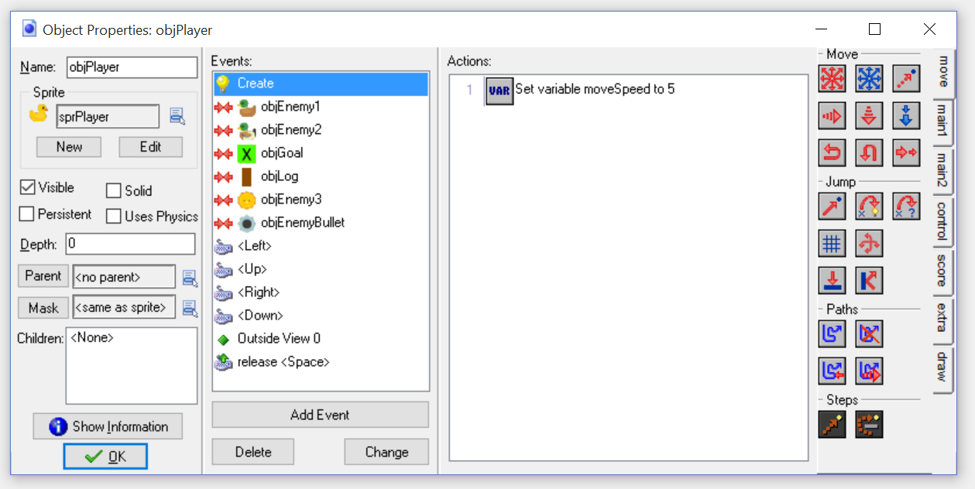

### Collision – Enemy 1

* Destroy Other

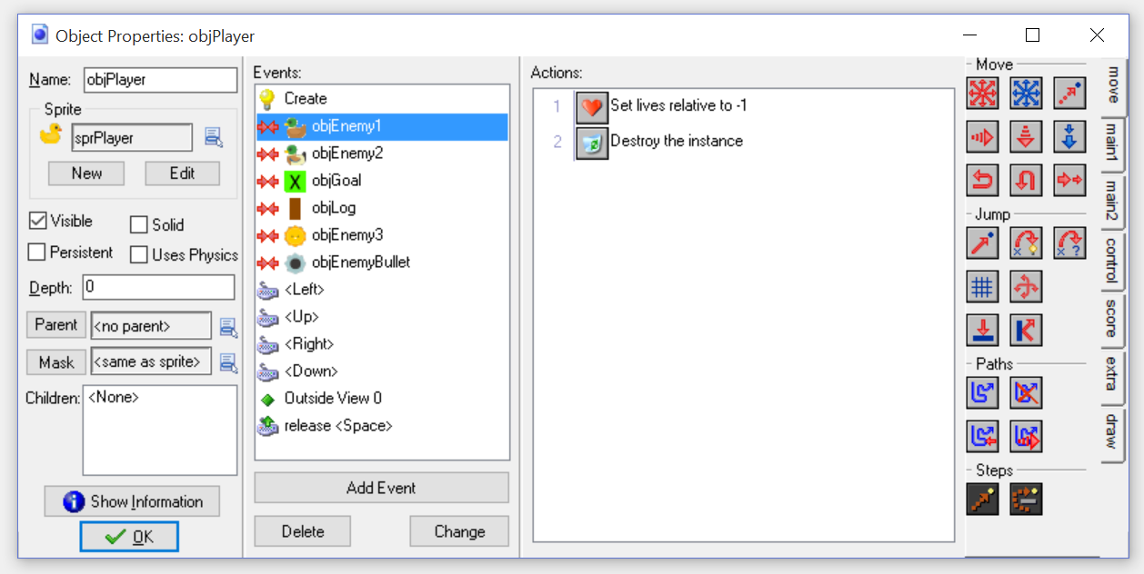

### Collision Enemy 2

* Destroy Other

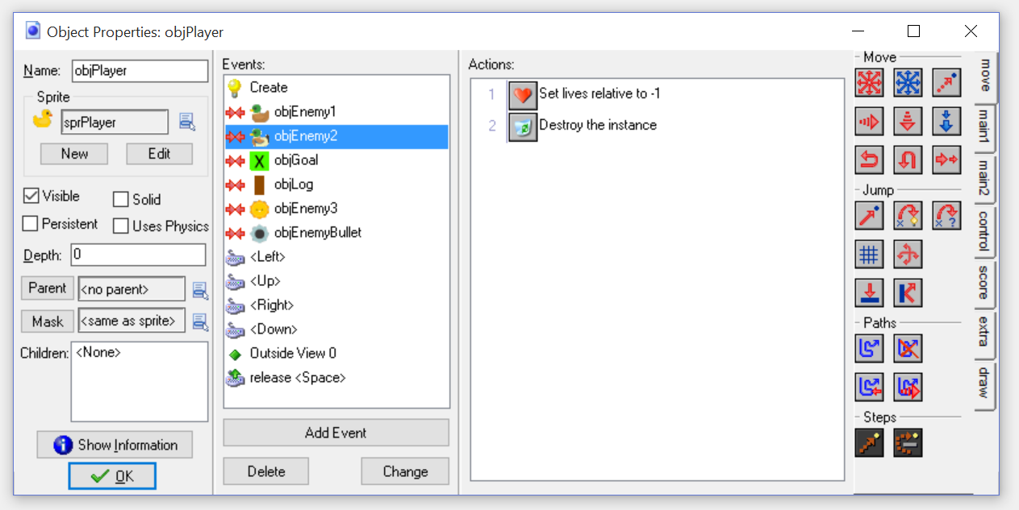

### Collision – Enemy 3

* Destroy Other

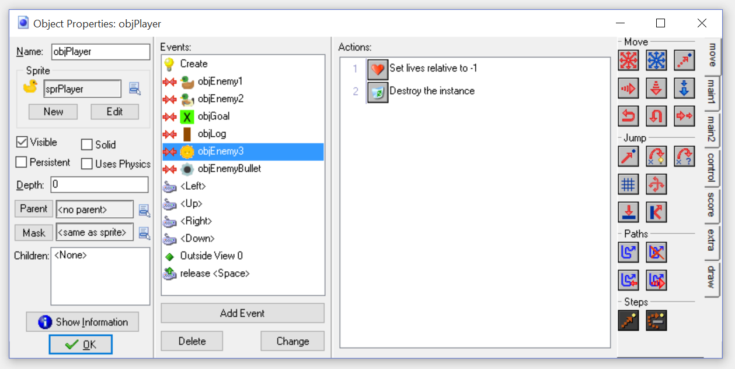

### Collision – obj Log

* Simply add an empty comment

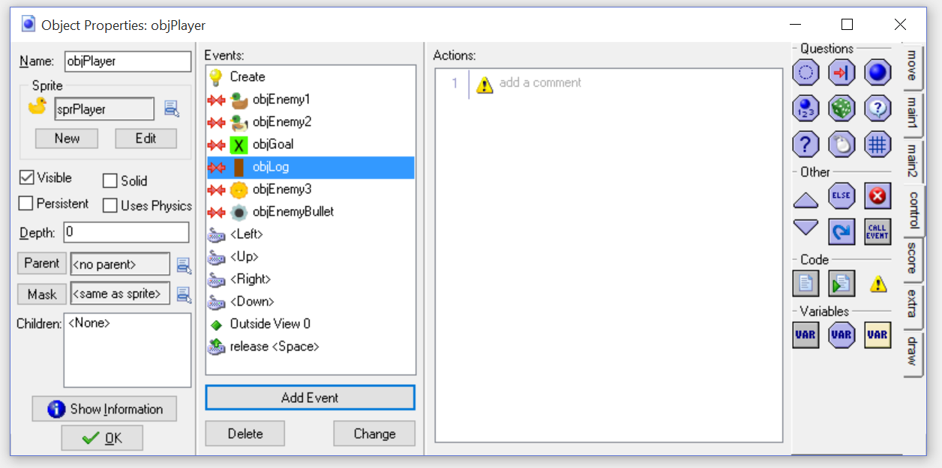

### Collision - Obj Goal

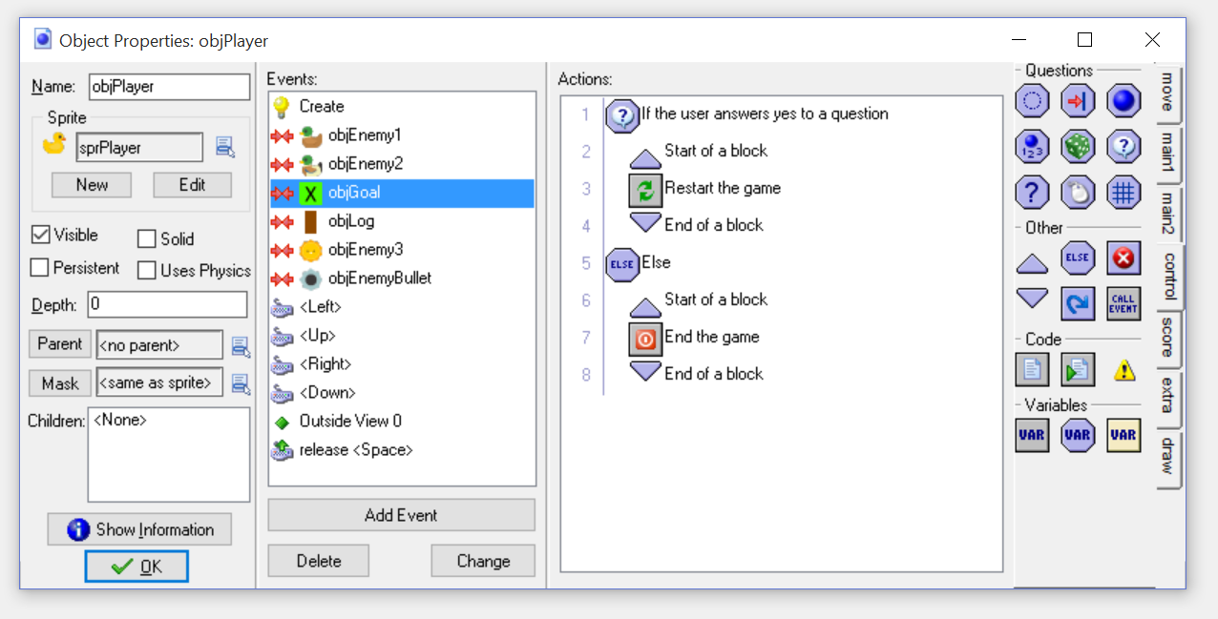

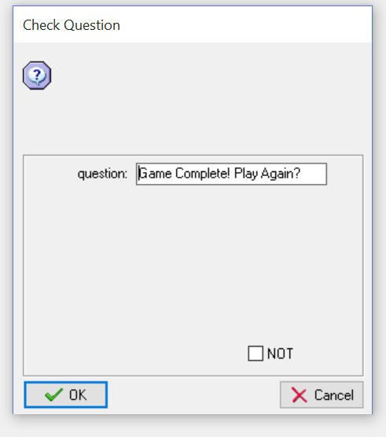

### Other – Outside View 0

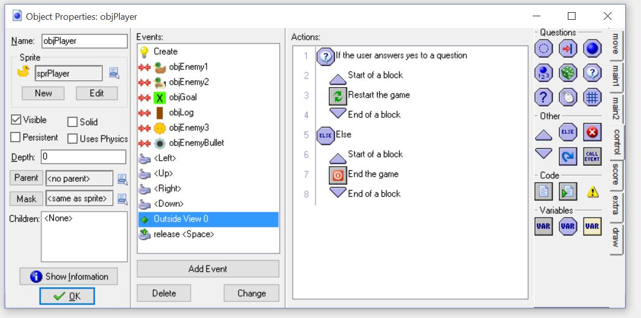

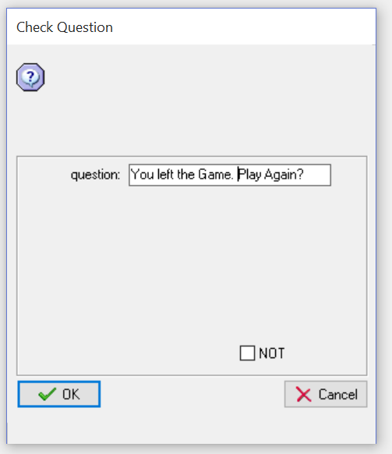

### Keyboard – Left Key

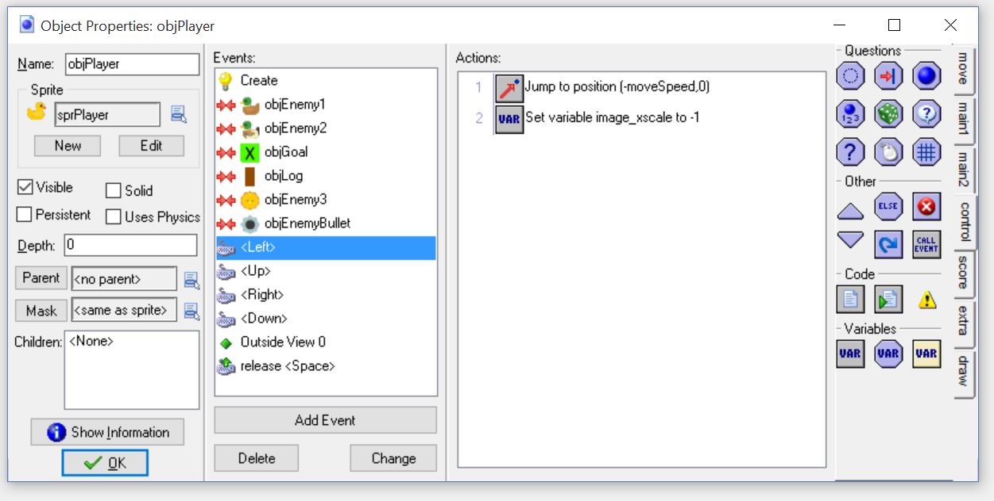

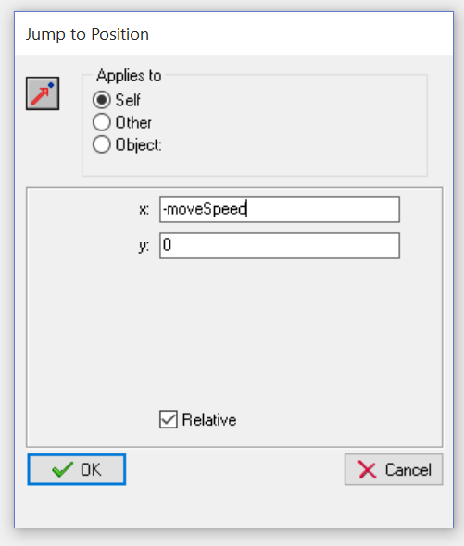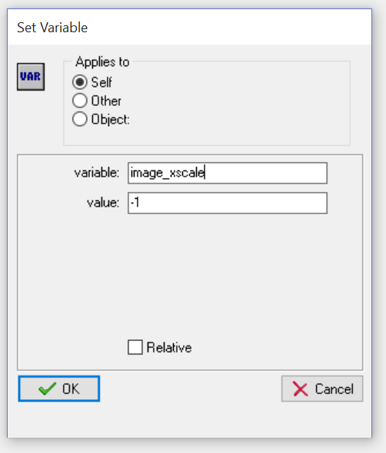

### Keyboard – Right Key

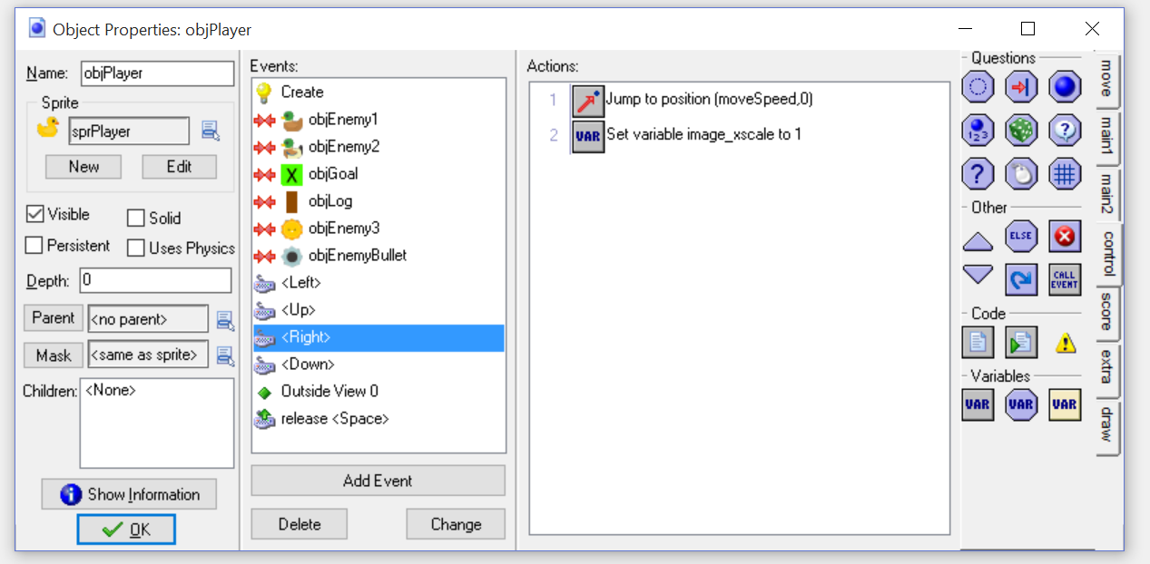

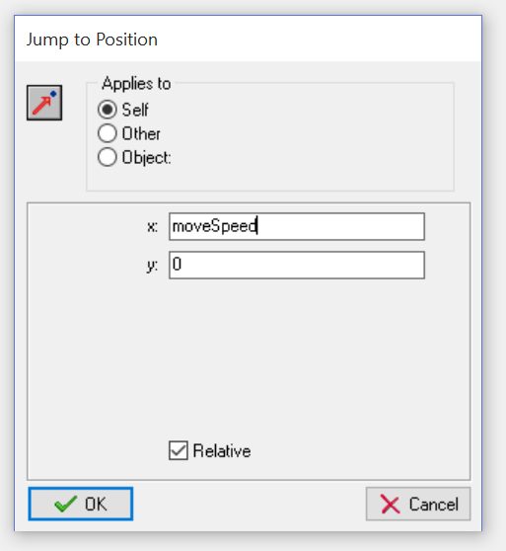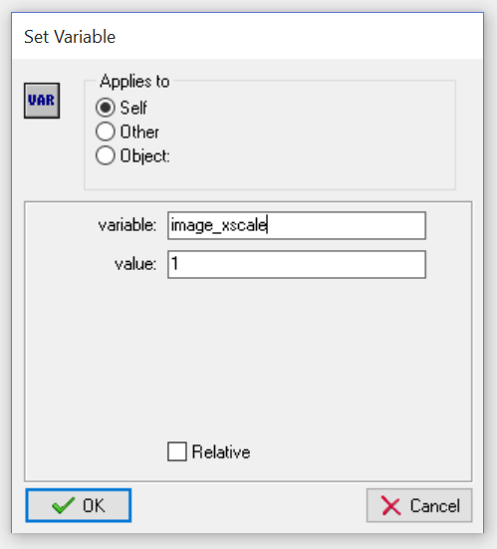

### Keyboard – Up

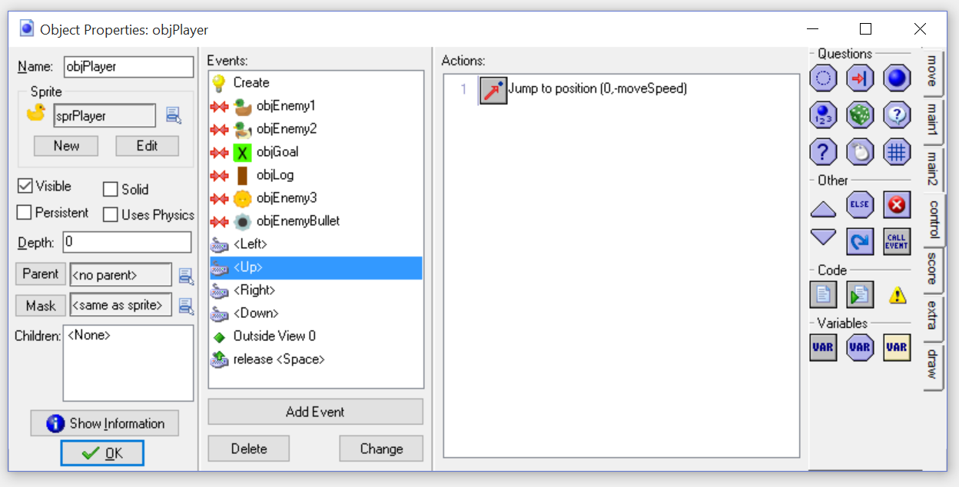

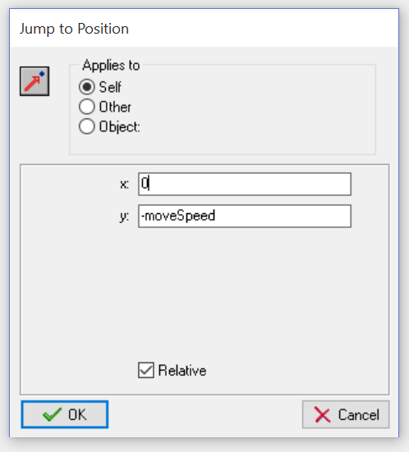

### Keyboard – Down

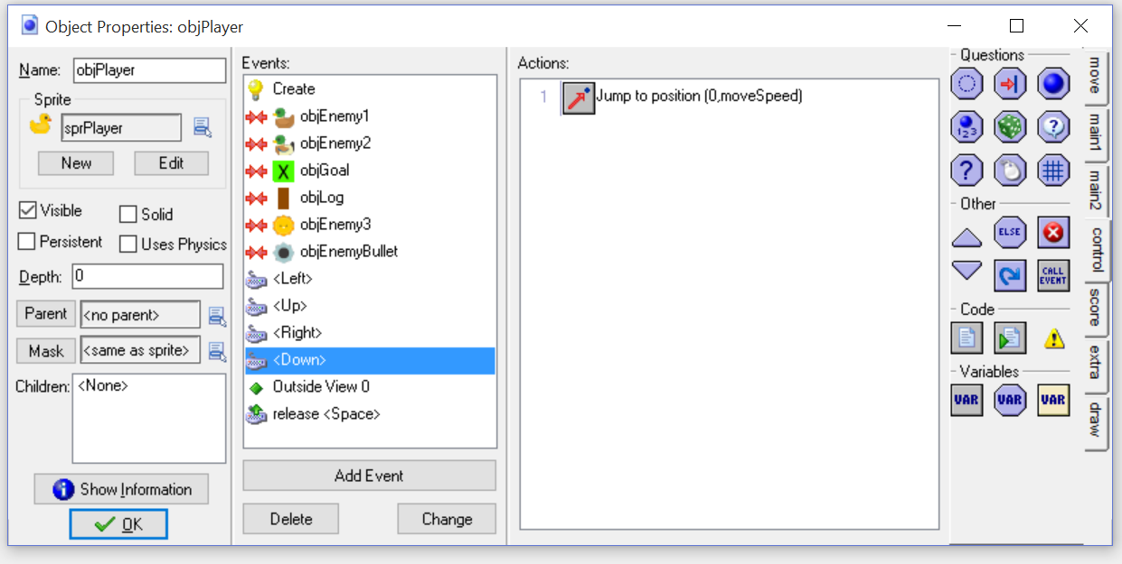

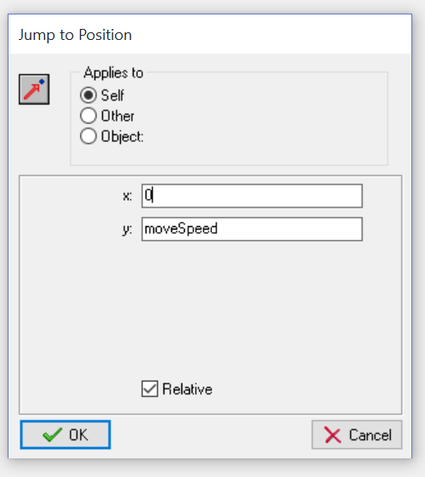

### Keyboard – Release SPacebar

